Date:04-07-2022

Program 2: Write A Program to implement Linear Search.

Code:

#include<stdio.h>

int main()

{

int size,a[20],i,value;

printf("the size of the array:");

scanf("%d",&size);

printf("enter array:");

for(i=0;i<size;i++)

{

scanf("%d",&a[i]);

}

printf("enter the element to be searched: ");

scanf("%d",&value);

for(i=0;i<size;i++)

{

if(a[i]==value)

{

printf("the value is found and at the position: %d",i+1);

}

}

return 0;

}

Output:

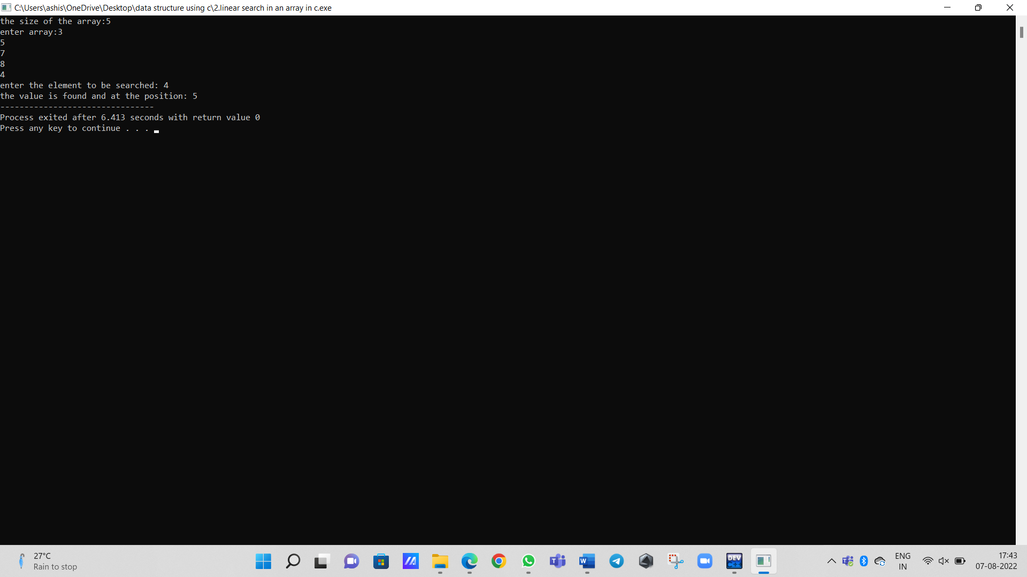

Program 3: Write A Program to implement Binary Search.

Code:

#include <stdio.h>

int main()

{

int a[20],ub,lb=0,mid=(lb+ub)/2,value,i;

printf("enter size of array");

scanf("%d",&ub);

printf("enter array elements");

for(i=0;i<ub;i++)

{

scanf("%d",&a[i]);

}

printf("enter value");

scanf("%d",&value);

while (lb<=ub)

{

if (a[mid]==value)

{

printf("element is present in the array");

break;

}

else if (a[mid]>value)

{

ub=mid-1;

}

else

{

lb=mid+1;

}

mid=(lb+ub)/2;

}

return 0;

}

Output:

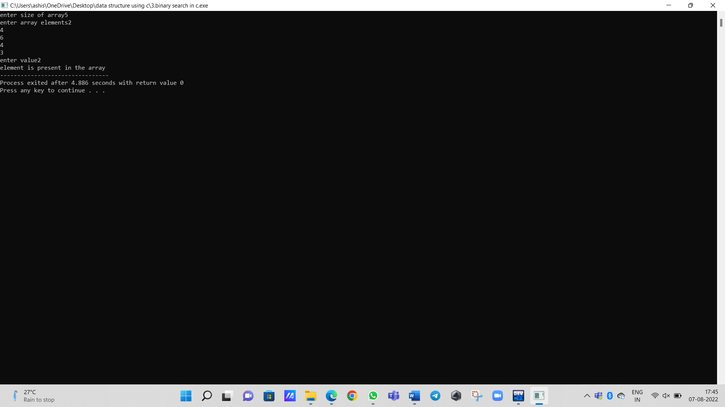

Program 3: Write A Program to implement Binary Search.

Code:

#include <stdio.h>

int main()

{

int a[20],ub,lb=0,mid=(lb+ub)/2,value,size,temp,i,j;

printf("enter size of array:");

scanf("%d",&size);

printf("enter array elements:");

scanf("%d",&a[i]);

for(i=1;i<size;i++)

{

scanf("%d",&a[i]);

}

for(i=0;i<size-1;i++)

{

for(j=0;j<size-1;j++)

{

if(a[j]>a[j+1])

{

temp=a[j];

a[j]=a[j+1];

a[j+1]=temp;

}

}

}

printf("the sorted list is:");

for(i=0;i<size;i++)

{

printf("%d\n",a[i]);

}

printf("enter the element to be searched: ");

scanf("%d",&value);

ub=size;

while (lb<=ub)

{

if (a[mid]>value)

{

ub=mid-1;

}

else

{

lb=mid+1;

}

mid=(lb+ub)/2;

}

if (a[mid]=value)

{

printf("element is present in the array at the position:%d",mid);

}

else

{

printf("the element is not found");

}

return 0;

}

Output:

